6. Financial Analysis
Two opposite financial profiles. Sun Pharma: revenue +11.6% CAGR (FY21–FY25), margin expanding to ~29%, net cash ~$3.1bn. Organon: revenue flat-to-declining (−0.3% CAGR), adj. EBITDA margin stable at ~31%, but ~$8.6–9.1bn of persistent debt and GAAP net income collapsing to $187m in 2025 on charges. Organon is a high-margin, high-cash-conversion, high-leverage asset in slow decline; Sun is a growing, lowly levered compounder.

6.1 Basis of analysis
- Fiscal years. Sun Pharma reports in INR to a 31 March year-end; Organon in USD to a 31 December year-end. Not calendar-aligned — normalised in the model.
- FX. Sun figures in INR; USD conversions at ~₹85.5/USD (FY25) where shown.
- Adjusted vs reported. Organon “Adjusted EBITDA” is management-defined (excludes IPR&D, restructuring, step-up). GAAP net income is shown separately.
- Confidence. FY23–FY25 (Sun) and 2023–2025 (Organon) figures are firm; earlier years and some margins are approximate, flagged, to be tied to annual reports/10-Ks.

6.2 Sun Pharma — five-year financials
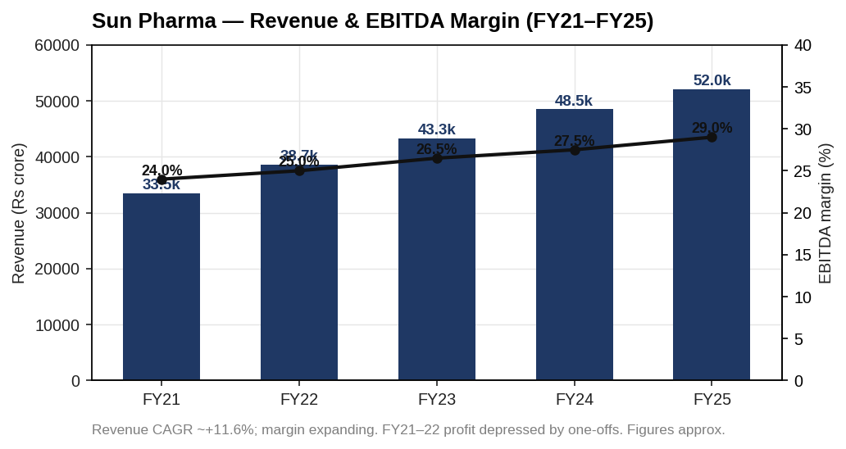
Sun Pharma revenue and EBITDA margin
₹ crore | FY21 | FY22 | FY23 | FY24 | FY25
Revenue | 33,498 | 38,654 | 43,279 | 48,497 | 52,041
EBITDA | ~8,040 | ~9,664 | 11,647 | ~13,337 | ~15,092
EBITDA margin | ~24% | ~25% | 26.5% | ~27.5% | ~29%
Net profit | 2,904 | 3,273 | 8,474 | 9,576 | 10,929
Revenue compounded ~11.6%. EBITDA margin expanded ~500 bps as specialty scaled. FY21–FY22 net profit was depressed by exceptional items (incl. a large US antitrust settlement); FY23 onward reflects normalised earnings — net profit ~3.8x from FY21 to FY25.

6.3 Organon — five-year financials
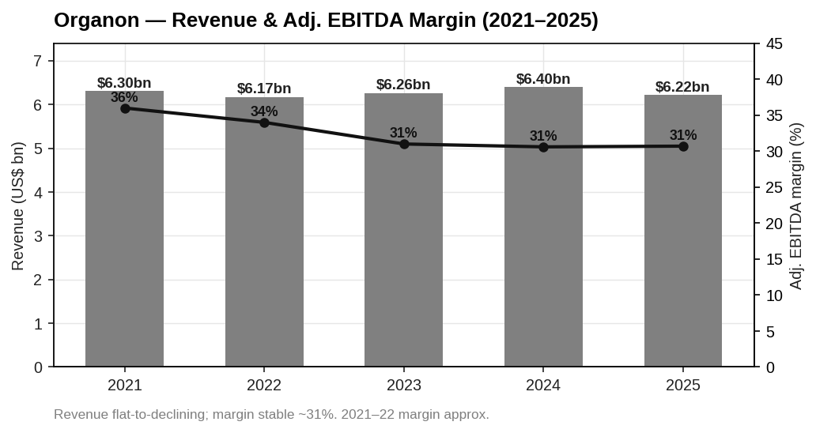
Organon revenue and adjusted EBITDA margin
US$ m | 2021 | 2022 | 2023 | 2024 | 2025
Revenue | 6,304 | 6,174 | 6,263 | 6,403 | 6,216
Adj. EBITDA | ~2,270 | ~2,100 | ~1,900 | 1,960 | 1,910
Adj. EBITDA margin | ~36% | ~34% | 31.0% | 30.6% | 30.7%
GAAP net income | n/a* | n/a* | 1,027 | 864 | 187
FCF before one-time | — | 875 | >1,000 | 967 | >900
Revenue has been flat within a $6.2–6.4bn band for five years — the definition of a mature, ex-growth base. Margin held at ~31%. The 2025 GAAP net-income collapse to $187m reflects charges/impairments, not an operating cliff; adjusted net income was ~$954m ($3.66/sh). Cash conversion is the strength: ~$0.9–1.0bn of FCF before one-time costs, year after year — the engine that services the debt.

6.4 Balance sheet and leverage
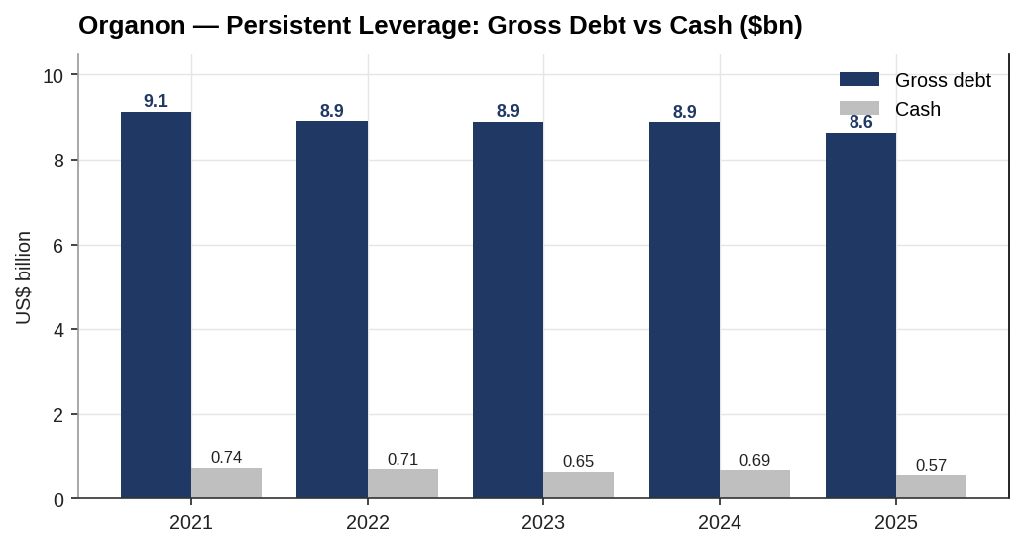
Organon gross debt vs cash
Organon has carried ~$8.6–9.1bn of gross debt since the 2021 spin, against <$0.75bn of cash — net debt ~$8.1–8.4bn throughout, i.e. ~4.2x net debt/adj. EBITDA. Deleveraging has been slow because FCF has partly funded the (since-cut) dividend. Sun, by contrast, sits on ~$3.1bn net cash (roughly −1.7x). The deal fuses the two balance sheets: Sun’s capacity absorbs Organon’s leverage, landing the combined group at ~2.3x.

6.5 Cash flow and capital intensity
- Organon. Low capex (mature portfolio), high FCF conversion (~$0.9–1.0bn/yr before one-offs). This is the deleveraging fuel.
- Sun Pharma. Higher reinvestment (R&D ~7–8% of sales, specialty and biosimilar pipeline), still strongly FCF-positive, funding the net-cash build.
- Working capital. Both carry pharma-typical inventory/receivables; no unusual swings disclosed. The Nexplanon channel-stuffing finding (Chapter 3) is a receivables/revenue-timing red flag to test in diligence.

6.6 Comparative ratio dashboard (FY2025)
Metric | Sun Pharma | Organon
Revenue growth (YoY) | +9% | (3%)
EBITDA margin | ~29% | 30.7%
Net margin (GAAP) | ~21% | 3.0%
Net margin (adjusted) | ~21% | ~15%
Net debt / EBITDA | ~(1.7x) net cash | ~4.2x
ROE (est.) | ~15% | distorted (low equity)
ROIC (est.) | ~15%+ | ~9–10%
FCF (before one-time) | strongly positive | ~$0.9–1.0bn
Capex intensity | moderate (pipeline) | low (mature)
Positive figures are the norm for Sun; Organon’s headline weakness is leverage and the GAAP net-margin optics, not operating cash generation.

6.7 Conclusion
The financials frame the deal precisely. Organon offers a stable ~31% margin and ~$0.9–1.0bn of annual FCF — enough to service and amortise the acquisition debt — but no growth and a heavy balance sheet. Sun offers growth, margin momentum and the balance-sheet capacity to carry the leverage. The combination works if Organon’s FCF holds while Sun deleverages; it fails if established-brands decline (or the Nexplanon issue) erodes that FCF faster than modelled. Chapter 7 values the target on this base; Chapter 8 tests the combined leverage and accretion.

Assumptions & sources
- *Organon GAAP net income for 2021–2022 not shown (to be confirmed from 10-K); 2023–2025 are reported ($1,027m / $864m / $187m). Adjusted net income 2024/2025 = $1,065m / $954m.
- Sun Pharma EBITDA for FY21/FY22/FY24 is approximated from revenue × estimated margin; FY23 EBITDA (₹11,647cr, 26.5%) and FY25 EBITDA (~₹15,300cr) are reported. Revenue series is reported consolidated revenue from operations (approx.); tie to annual reports.
- Organon adj. EBITDA 2021–2022 (~$2.27bn / ~$2.10bn) estimated; 2023–2025 reported ($1.9bn / $1.96bn / $1.91bn).
- Organon debt/cash per 10-K/earnings: gross debt $9.13bn (2021) → $8.64bn (2025); cash $0.74bn → $0.57bn.
- ROE/ROIC are illustrative estimates pending full balance-sheet build in the model.
- FX ~₹85.5/USD (FY25).
Sources: Sun Pharma FY21–FY25 results and annual reports; Organon Q4/FY 2021–2025 earnings releases and 10-K; Macrotrends/StockAnalysis for cross-checks. Full sourcing in 05_Data/DATA_SOURCES.docx.

